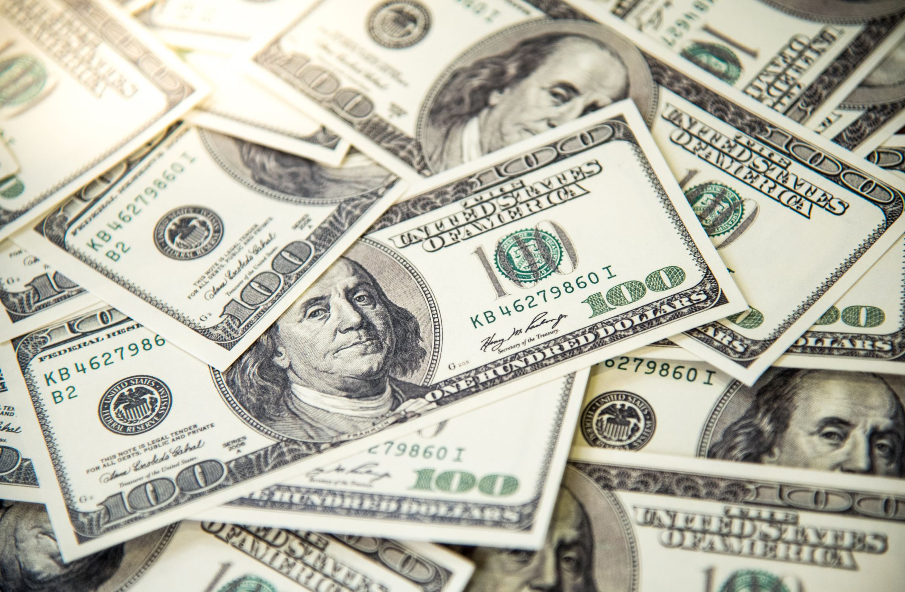

The Conundrum of Legalized Gambling:
Tyler Foti

Executive Summary:
It is Saturday morning, you woke up, had your coffee and you turn on your TV to watch “ESPN’s College Gameday.” Fast forward a couple of hours it is now 11:45 A.M. Ashton Kutcher has just walked onto the set of “gameday”, to make his guest picks. The cast starts off with Oregon at UCLA Reece Davis sets the stage; Oregon is 6-0 on the season and UCLA is 1-5 on the season. Oregon opens as a 24.5-point favorite. This means that the people placing bets on the game around the country, believe that Oregon will win by more than 24.5 points. Desmond Howard picks Oregon to cover (win by more than 24.5), Ashton Kutcher picks Oregon to cover, Kirk Herbstreit picks Oregon to cover but Lee Corso says I am going to pick UCLA to shock the world and beat the Ducks.
I think to myself, let’s try to make some money off Lee Corso’s pick. I, while sitting on my couch login to my BETMGM app on my phone. I pick UCLA to be an outright winner. Fast-forward 12 hours, it is now 11:55 PM local time. Oregon has just defeated UCLA 45-16. Consistent with my luck, I login in to my BETMGM app, and I have just lost $20 by picking UCLA to upset Oregon. I decide then and there, I am never going to place another bet again. On that Saturday alone, individuals have placed hundreds of thousands of dollars’ worth of bets and have not reaped any of the rewards, they lost the money. The gaming conglomerates are profiting all that money and only being taxed at an 8.4 percent tax rate here in Michigan.
Context:
Let’s backtrack my day, I turned on my television, heard an analyst make a prediction, signed into an app on my phone, placed a bet, watched a game, and lost 20 dollars. Five years ago, I would not have been able to do that unless I lived in Nevada. For years, individuals were trying to break Nevada’s monopoly on a billion-dollar industry. Countless court cases all the way up to the Supreme Court, billions of dollars paid to lobbyists to keep that monopoly and years of trying. It had to start somewhere. That took Governor Chris Christie taking on the entire gaming lobby.
For years, Nevada was the only state where it was legal to place bets on sports due to the Professional and Amateur Sports Protection Act of 1992, which established sports betting as illegal throughout the United States of America. The Act did create an opportunity for states other than Nevada to legalize sports gaming by establishing a one-year window for states which operated licensed casino gaming for a significant period to pass laws permitting sports wagering. (Rotifer, 2007)
After losing in court for the better part of seven years, Christie appealed to the Supreme Court, which decided in favor of New Jersey, in a 7-2 decision that “PAPSA” violated the 10th amendment. Sports gambling was now legalized in New Jersey and subsequently the rest of the United States. This ruling opened the floodgates; thirty-three states have moved to legalize sports gambling to varying degrees. Thirteen states have full mobile betting, twenty states have now passed sports betting legislation. (Butler, 2021)
How does a stay prepared for a problem that they didn't see coming? Gambling had been illegal in every state but in Nevada forever. Chris Christie had been unsuccessful for seven years breaking the gaming lobby, but New Jersey had the infrastructure in place hoping that someday, they would break the monopoly of Nevada. Michigan did not really see this coming just like every other state. A bill to legalize sports gambling in Michigan, after the Supreme Court ruled was blocked by then Governor Snyder.
When Gretchen Whitmer took office, she was open to passing hey legalized gambling bill. Just like most things in the Michigan legislature, it became a Standoff between a republican legislature and a democratic governor. The conservatives in the House and Senate, were steadfast on 8.4% tax rate and governor Whitmer wanted a 15% tax period a 15% tax on gross sports betting receipts, was not feasible politically. After a negotiation that took for a better part of the year, governor Whitmer threatened to veto the final version of the house bill if the Senate passed an 8.4% tax. Handcuffed by a 35-3 Senate vote with almost all Democrats voting affirmative, governor Whitmer had no choice but to sign the bill. I'm not saying pass a 15% tax because that is not politically feasible, but if the Republicans in the House and Senate were not so steadfast on driving competition then we would have additional revenue to supplement the problems that legalized gambling creates. Looking forward, we will continue to dive in and see if this notion of a lower tax rate driving competition was worth the problems that legalized gambling is leaving behind.

The First Issue: Taxation:
In Michigan, gross sports betting receipts are taxed at 8.4% which is extremely low, one of the lowest in the nation. According to Michigan Sharp, the sports betting handle in the month of March(2021) is expected to generate $650 million. March is a very popular month for sports betting the NCAA tournament, NBA and the NHL are all in the thick of their seasons. Michigan Sharp, expects March is handled to be 1/4 of the total 2.3 million projected of the tax revenue for betting. $3.7 billion was wagered in the state of Michigan in 2021, that is missing the month of January when it was not legal. It generated $208.94 million in tax revenue. If Michigan would tax the winnings at the same rate as New Jersey, Indiana and Illinois; then it would have generated $555 million in revenue. Think of what that can go to fixing the roads, education, support for gambling addicts and so much more. Michigan is leaving $346 million dollars on the table annually, that is a crime. With all this revenue coming in it creating a problem, more problem gamblers.
The Second Issue: Gambling Addiction:
In Michigan there is a developing epidemic in younger children becoming sports gambling addicts. You might say, how old does a middle school or high school aged child become a gambling addict? The Michigan Department of Health and Human Services stated that since gambling became legal in the state, they have started focusing they're prevention on middle school and high school age children. When I was an adolescent, I was aware that you can gamble on sports in Las Vegas. But if you asked me about what the betting line of the Suns versus Pelicans game tonight , I would have no idea that the Suns are favored by 6 1/2 points. One of my favorite things as a kid was waking up in watching Sports Center. When I watch Sports Center now, every betting line is on the bottom ticker on the screen it's right in front of you.
The 1990s, The National Opinion Research Center found that living in a 50-mile radius to a casino made the individual twice as likely to become a problem gambler. (NORC,1996) Now with it being so easy that you don't even have to leave your house to place bets, pho ne calls to gambling helplines are doubling each month. The month before online gambling became operational in Michigan, it took 218 gambling calls, after just one month it already took 563 calls. In November of 2021, it had took 853 calls a day. (Michigan Sharp, 2022) Mental Health experts, call gambling addictions the silent assassin because nobody knows the person is suffering. People need help now.
Michigan going forward is not going to have enough money to support all of the problem gamblers they are creating. With the tax rate being 8.5% of all gross betting receipts it is going to be extremely hard to find the support resources problem gamblers are going to need. Please don't think this is me saying that gambling should be illegal because I don't think it should but it needs to be regulated correctly and tax correctly so we can fund the support resources correctly.
The Third Issue- Integrity of Sports:
When Governor Christie originally wanted to make sports gambling legal in New Jersey, all major sporting leagues were vehemently opposed. Almost a decade later, sports leagues started to accept the fact that legalized gambling would be happening in the next few years. Well, you may ask what changed come or change was a few commissioners changing and people like Gary Bettman and Roger Goodell coming around to the issue of legalized sports gambling. the turning point was when the Supreme Court decided they were going to listen to Chris Christie's case against “PAPSA”, where the sports league started reading the writing on the wall and came around and ended their objection.
Fast forward to modern day, the major sports leagues involve sports gambling in their everyday business. As I am writing this, I am watching the MLB Network. On the bottom ticker, it says Detroit versus Minnesota, the money line for Detroit to win is +168, the money line from Minnesota win is -199 and the over under is set at seven runs combined. This is a television channel that is run by Major League Baseball. The NFL is guilty of the same. And if you look at literature online, the NFL urges their viewers to watch the game on Sunday and bet using Caesars sportsbook.
Now that the act of sports gambling is legal, leagues must monitor if their players are gambling on sports which is against league rules. Two notable occurrences of players being accused or wagering on games, are Calvin Ridley of the Atlanta Falcons and Evander Kane of the San Jose Sharks hockey team. Evander Kane was accused by his ex-wife, in a nasty divorce Evanders ex-wife stated that the Evandor would gamble on games. After a long investigation and resources provided by the NHL, Evander was cleared of any wrongdoing and the allegation was proved false. Calvin Ridley was not so fortunate; he was caught wagering $1500 throughout the NFL season. Calvin was subsequently suspended for the entire 2022-23 season. the NFL wanted to make an example out of Calvin. There is the issue of keeping the integrity of sports in a world where gambling is legal. It is invaluable to make sure that the integrity of sports is kept intact. Without integrity sports can become obsolete. That sounds like a brash statement but if you have a bunch of players wagering, even if it's for their own team to win it hurts the integrity of the game. Over the next number of years, I believe it's going to become a bigger issue and it's up to leagues to keep the integrity intact.

Recommendations:
My first recommendation regarding taxation, is to raise the tax rate on gross sports betting receipts to 12.5%. Why 12.5%, well it's higher than 8.5%. in all seriousness 12.5% seems to be the most politically feasible number state government could get to, being that it is split between Republicans and Democrats and will most likely be for the next few years. Raising the tax rate to 12.5% will give the state more revenue for the general fund to fix issues like the roads, education and contributing to help for problem gamblers.

My second recommendation is as follows. Create a federal guideline to cap a daily wager amount at $400 per individual. This might be a bit ambitious but at some point, you must protect people from themselves. Drinking alcohol is perfectly legal but drinking absorbent amounts of alcohol and then doing something to harm yourself, like driving is illegal. It might take a few years for people to come around to a federal guideline on sports gambling, but I think there is an appetite for that. I am not saying to stop at a daily wager caps. I am open and encourage the federal government to step in and create uniform guidelines for sports gambling. If there were federal guidelines that in uniformity, I believe that would help state governments navigate the muddy waters of legalized sports gambling.
The third and final recommendation, is to have the sports league take a chunk of money out of there television contracts and use it towards helping problem gamblers find resources and keeping integrity in the sport. I can understand how people would think this is a radical idea, but these television contracts nowadays are massive and there is so much money to go around. If the leagues contribute 10% of that contract it could be a massive improvement of people’s daily lives.
Conclusion:
I believe in two years; people will start thinking of this topic and start seeing that it needs change. The inundation of advertisements and sports betting lines involved in the experience of watching a game is creating a whole new wave of gamblers. This is a very important issue and I hope that people will remember my work as visionary.
I want to leave you with one quick story. I was in middle school, and I remember sneaking off to the bathroom to stream the NCAA tournament on my phone. It wasn’t because my dad or an older friend bet $20 on Michigan State to win, or because I wanted a perfect bracket. It was because of the pure joy sports brought me. I think the younger generation will lose that and that is a travesty.

Works Cited:
Boesen, U. (2020, August 6). Sports betting might come to a state near you. Tax Foundation. Retrieved October 26, 2021, from https://taxfoundation.org/legal-sports-betting-states/.
Play Illinois. (2021, October 12). Illinois sports betting revenue - monthly and all-time. Illinois Sports Betting Reports. Retrieved October 26, 2021, from https://www.playillinois.com/revenue/.
Bloomberg. (n.d.). Sinclair Rebrands. Bloomberg.com. Retrieved October 4, 2021, from https://www.bloomberg.com/news/articles/2020-11-18/sinclair-is-said-to-rebrand-sports-networks-with-bally-name.
Gerlacher, W. B. C., & About the AuthorChristopher GerlacherChristopher Gerlacher is a writer tucked into the foothills of Colorado Springs. (2022, March 10). Michigan March Madness expected to generate $530,000 in tax revenue. Michigan March Madness Expected to Generate $530,000 In Tax Revenue. Retrieved April 27, 2022, from https://www.michigansharp.com/michigan-march-madness-expected-tax-revenue/
History of gaming in Nevada. The History of Gaming in Nevada. (n.d.). Retrieved October 4, 2021, from https://www.nevadaresorts.org/about/history/.
Paspa: Sports Protection Act. Let’s Gamble USA. (n.d.). Retrieved October 4, 2021, from https://www.letsgambleusa.com/federal-gambling-laws/paspa-sports-protection-act/.
Purdum, D. (2017, March 29). Roger Goodell says NFL still opposed to legalized sports betting. ESPN. Retrieved October 4, 2021, from https://www.espn.com/chalk/story/_/id/19027576/nfl-commissioner-roger-goodell-says-league-opposed-legalized-sports-betting-raiders-moving-las-vegas.
Purdum, D., & Rodenberg, R. (2018, May 14). The odds of legalized sports betting: New Jersey vs. the leagues. ESPN. Retrieved October 4, 2021, from https://www.espn.com/chalk/story/_/id/22605881/new-jersey-vs-leagues.
Steve. (n.d.). History of sports betting in the USA. LegalSportsBetting.com. Retrieved October 4, 2021, from https://www.legalsportsbetting.com/history-of-sports-betting-in-the-usa/.
Thompson, C. (2021, May 5). Online betting launched in January. then, calls to Michigan's gambling helpline spiked. Lansing State Journal. Retrieved October 4, 2021, from https://www.lansingstatejournal.com/story/news/2021/04/28/calls-michigan-gambling-helpline-up-online-sports-betting/4852729001/.
“Calculating Taxes on Gambling Winnings in Michigan.” Calculating Taxes on Gambling Winnings in Michigan, www.greatlakesstakes.com/gambling-winnings-tax.
Draper, Kevin, and Nick Corasaniti. “Christie Looks to Sports Gambling for a Rare Second-Term Victory.” The New York Times, The New York Times, 3 Dec. 2017, www.nytimes.com/2017/12/03/sports/sports-betting-supreme-court-chris-christie.html.
Hoffman, Amber. “How Does Online Gambling in Michigan Compare to Other States.” How Does Online Gambling in Michigan Compare to Other States, 6 May 2021, www.michigansharp.com/us/?
“Online Gambling Tax Rates Run the Gamut across Us States.” PA Online Casino, 14 Jan. 2020, www.paonlinecasino.com/7457/online-gambling-tax-rate-comparison/.
Reindl, JC. “Michigan Legal Online Gambling and Sports Betting to Start Friday.” Detroit Free Press, Detroit Free Press, 22 Jan. 2021, www.freep.com/story/money/business/2021/01/19/michigan-online-gambling-sports-betting-starts-friday/4215139001/.
Welman, J. (2021, October 18). Michigan Online Sports Betting Revenue Tracker: Handle by month. Michigan Online Gambling. Retrieved October 26, 2021, from https://www.playmichigan.com/sports-betting/revenue/.

